LCC Scheduling System User Manual

Installation:

The program is stored as a compressed (.zip) file.
To install, simply unzip the file into the proper location.

Running the program:

To run the program, double click on "LCC Scheduling System.exe" in the application's folder.
Note: If a file was already begun for the current month, the program will ask you if you would like to open that file. If you select no, it will overwrite that current month’s file when ‘Save Entry’ is clicked. If you select yes, the file will load and you can continue where it was left off.

The program:

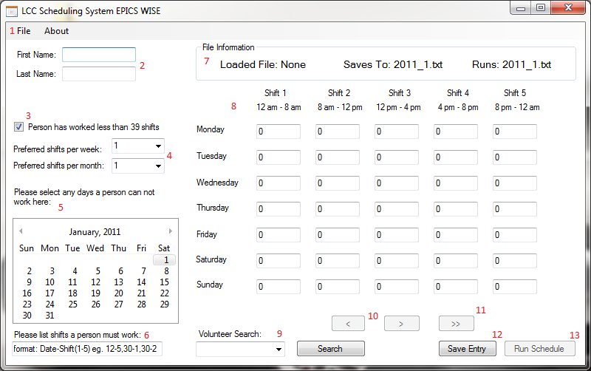

- File – This option will bring down a drop-down which will allow the user to load a file.
- Name – This is the volunteer’s name. A first and last name must be entered to save an entry.
- 39 Shift Requirement – This checkbox, if unchecked will allow the program to give more shifts to the volunteer.
- Shift Preferences for week and month – The volunteer’s shift preferences. 0-7 shifts per week may be selected, and 0 – 31 shifts per month may be selected.
- Days off – The days that the user can not work. Bolded dates are the days that will be assumed as dates that cannot be worked by the volunteer. Selecting a date will bold it (and therefore be listed as a day off). Selecting a bolded date will unbold it (and therefore be removed from the days off list).
- Days that Must be worked – This is a list of days/shifts that must be worked.
Format: Date-Shift, Date-Shift
Ex: 30-4, 30-5
(November 30th from 4 - 8pm & 8pm -12am)
Where Date is the day of the month, and shift is a number 1-5 as specified on the right.
Note: Error checking for this section is not enabled. The format must be entered correctly or it will cause the days that must be worked not to be recorded correctly.
- File Information – This section of the interface displays which file has been loaded into the program, where the entered data will be saved, and which file that has been created will be executed when a schedule is created. The format of these file names will be “year_month.txt”.
- Shift Preferences – A schedule for each day of the week, and 5 different shift times. The schedule will be repeated for every week of the month. Preferences from 0-3 are accepted. Any other entries will produce errors and the program will notify you of those errors.
- Search – Allows previously entered volunteer’s data to be found and edited by searching the volunteer’s name. See below for more information on how to use this feature.
- Arrow Buttons – Allow you to navigate through the volunteers one-by-one in the direction navigated by the arrows.
- Double Arrows – Returns to the end of the list and allows for a new entry.
- Save Entry – The button to save the current entry.
- Run Schedule – This button will run the completed schedule after all data has been entered and saved. It will produce results in an .ics file type. See below for more information on how to run the schedule. Clicking this button will produce a different schedule every time.

Inputting data for a new schedule:

On startup, by default, the program initializes a data file for the next month if one hasn’t been previously created, based on the time and date on the user's computer.

Type in the name and preference information for the first volunteer, then click the "Save Entry" button. Repeat this process for each volunteer. When all data has been entered, click the "Run Schedule Button." The program will then create the schedule and send it to Microsoft Outlook for display.

Saving

The file saves every time the “Save Entry” button is clicked. This file will be saved and located in the installation directory of the program.

Loading from previous or in-progress schedule (of this month):

The user can load volunteer data from a previous schedule, even if the schedule was never completed. Click the "file" menu, then click "Load." Data saved from previous schedules is available in the installation directory of the program. Once the file browser window opens, select the desired file and click “Open”. Only files that were previously created with the program should ever be loaded. If an incorrect file is chosen, the program will notify you that it is not of the correct format. If the file that is selected is empty, the program will notify you that the loaded file was empty.

The user can then modify or add to the loaded data and create a new schedule, however the schedule will only be created correctly if it is executed the month before the schedule is to be used. If it isn’t executed before the first of the month, the number of shifts calculated to be scheduled by the program will be incorrect, resulting in either too few or too many shifts being scheduled.

NOTE: If the user loads previous schedule data and creates a new schedule, the program will provide a completely different schedule.

Retrieving/Reusing Old User Data
If you wish to use data from previous months, run the program as usual. On the top left, click File -> Load. Select the file from the month you wish to open. You can use the search bar to find the specific person you wish to use the data from. Once finding the desired person, you can edit the data and either save it back to the old file from the previous month, or there is also the option of saving this person’s data to the file for the next month. This will often be handy, because instead of re-entering every person’s data each month, an old file can be loaded, and then you can edit the old data and save it to a new file all in one operation.

Note: Make sure you only have one scheduling program open at a time. All necessary functions of the program can be completed from one instance of the program. If you need to get data from the old file, you must close the current month’s data first.

Finding/Updating Specific Volunteers

If you wish to locate a specific volunteer, click on the drop-down box (#9 in the figure above). This will bring a list of all volunteers that have already been entered into the current file. To filter the list, begin to type the name you desire. The list will update automatically, and if the person being searched for is not in the drop down menu, then that user is not currently in the file. When the user is found, select and click “Search”. The name must be typed in correctly; the best way to do this is to select the name from the filtered list.

Updates to volunteer data may be made, but “Save Entry” must be clicked to save the changed data.

Using the schedule in applications other than Microsoft Outlook

The schedule automatically sends the data to Outlook for display, but the user can use the schedule in other calendar readers. The program creates an ".ics" calendar file of the format "calendar-[year]-[month].ics". This file is stored in the application's installation directory. This file can be imported into any calendar reader software that supports this type of file (ex. Mozilla Sunbird, Google Calendar). See the documentation in the calendar reader software of your choice for instructions on how to import this file to that program.

Troubleshooting
- Make sure you have the file for the correct month open. You can only create correct schedules for files for the next month (Ex. December’s schedule can only be created in November in order for the correct number of shifts to be scheduled). The program uses your computer’s system date and time to determine the current month and day.
- Make sure your computer’s Month/Year/Date is set correctly.
- If for some reason you have multiple instances of the program open, try closing any extra instances of the program. All possible uses of this software can be done from one program window.
- Try to close the program and re-open it.
- In the event that you are unable to determine the issue that is causing the program to error out, please contact the EPICS WISE team at epics-wise@purdue.edu for further assistance. If the issue arises during the summer or during a break where the students may not be available for contact, please instead refer your questions and comments to the EPICS staff members at epics@purdue.edu.

